WEEK 7 SAI SHRUTI B

Importing the Student Performance Dataset
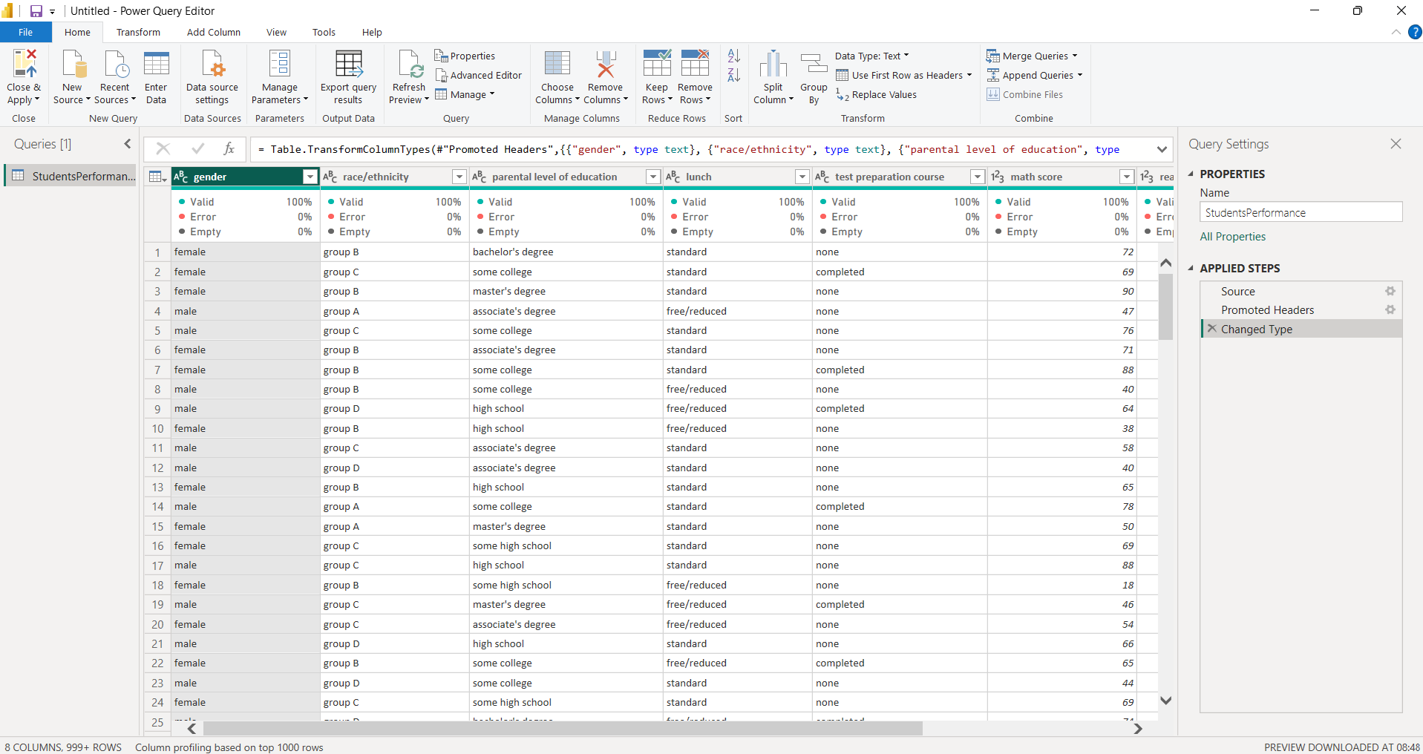
The Student Performance dataset was imported into Power BI and opened in Power Query. The dataset contains student information along with their math, reading and writing scores.

Cleaning Text Data
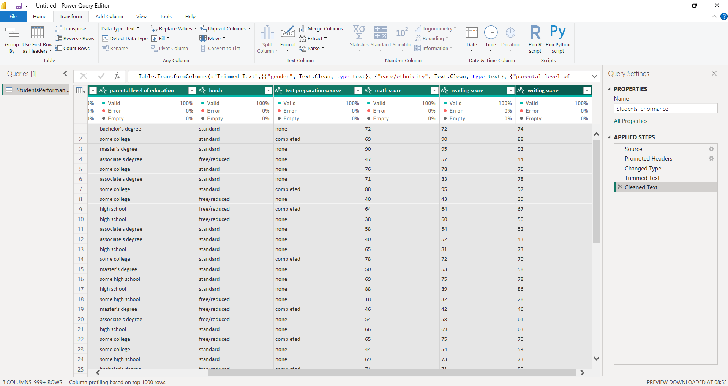
The text columns were cleaned using the Clean transformation. This was applied to remove unwanted characters and ensure that the categorical values were consistent.

Adding Student ID
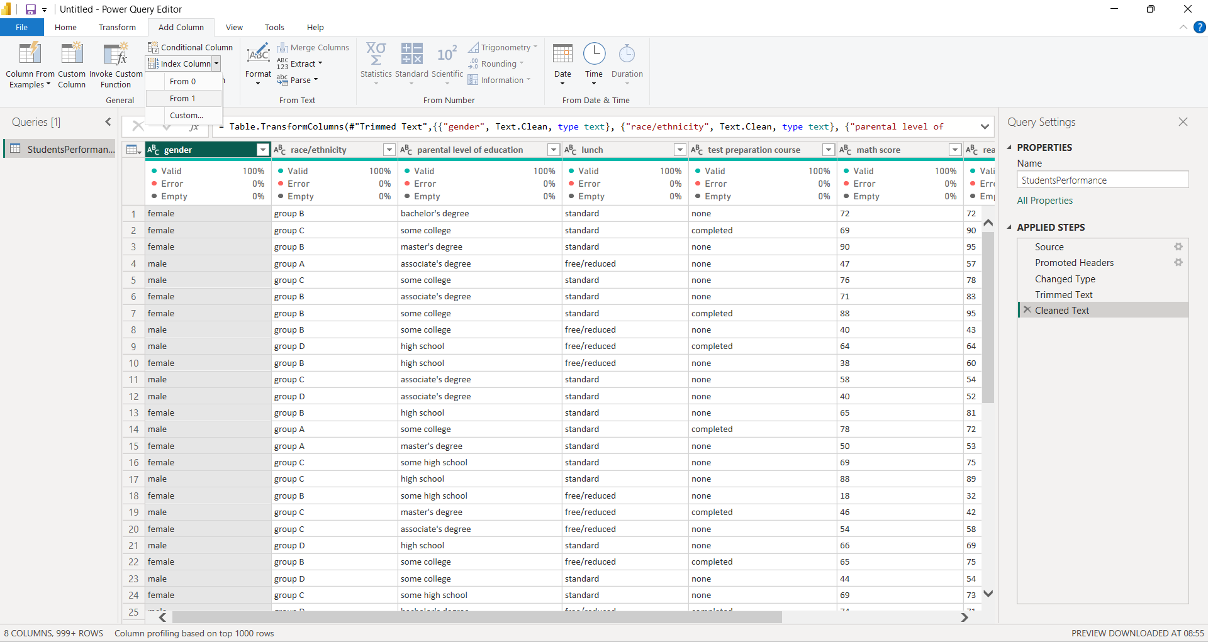
An Index Column was added to the dataset to create a unique identifier for each student. The index starts from 1 and was later used as the Student ID.

Renaming and Reordering Columns
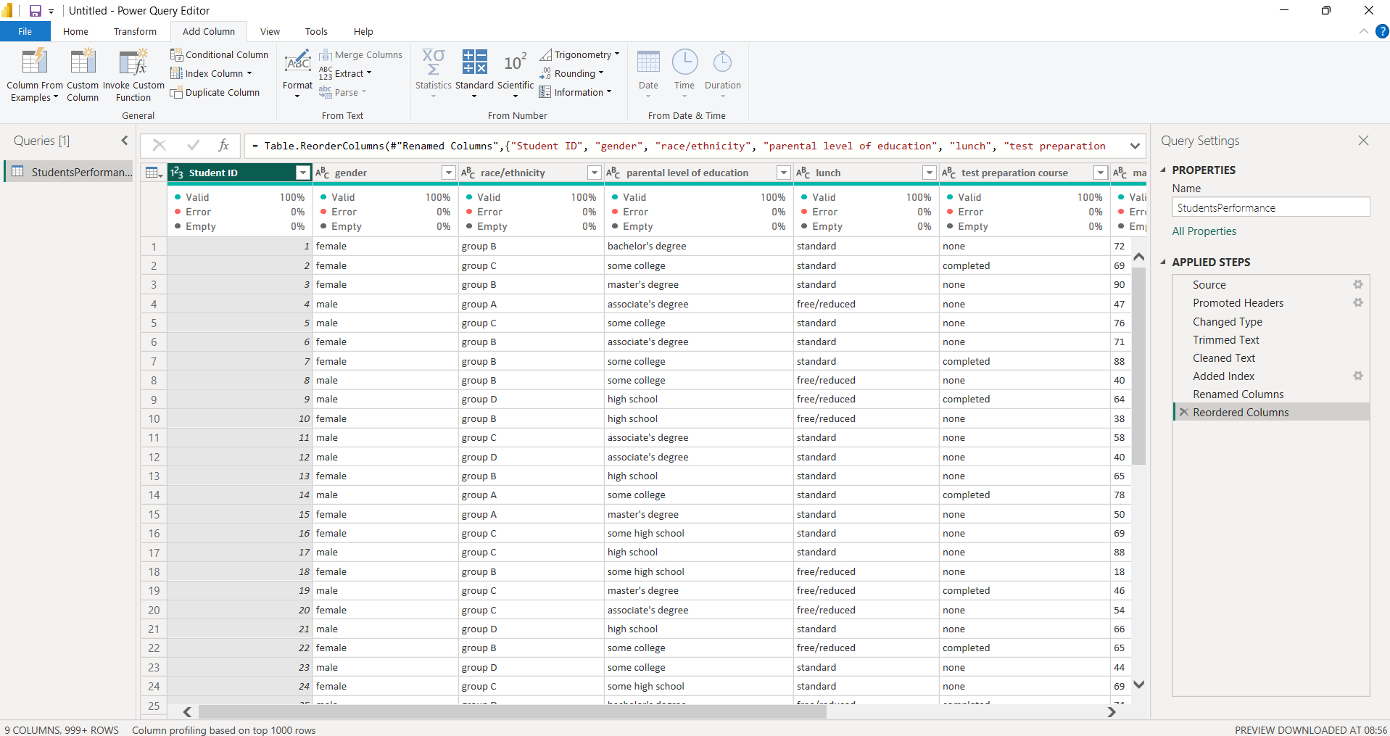
The index column was renamed as Student ID and the columns were reordered to keep the student information and score columns in a proper sequence.

Creating Total Marks
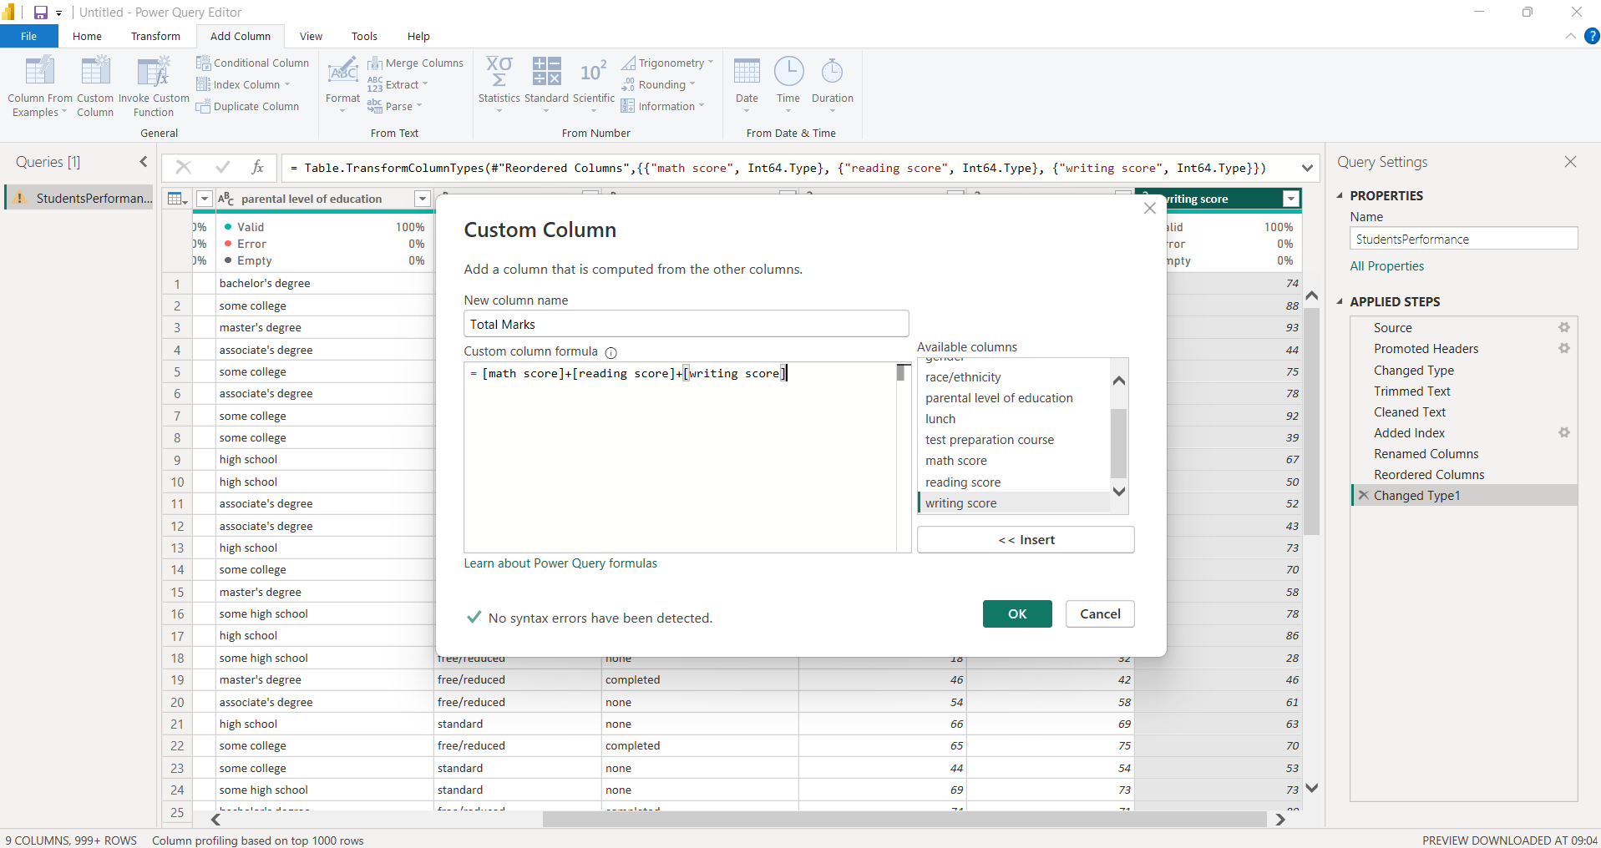
A custom column named Total Marks was created by adding the three subject scores.
The formula used was:
[Math score] + [reading score] + [writing score]
This gives the total marks obtained by each student across the three subjects.

Total Marks Column
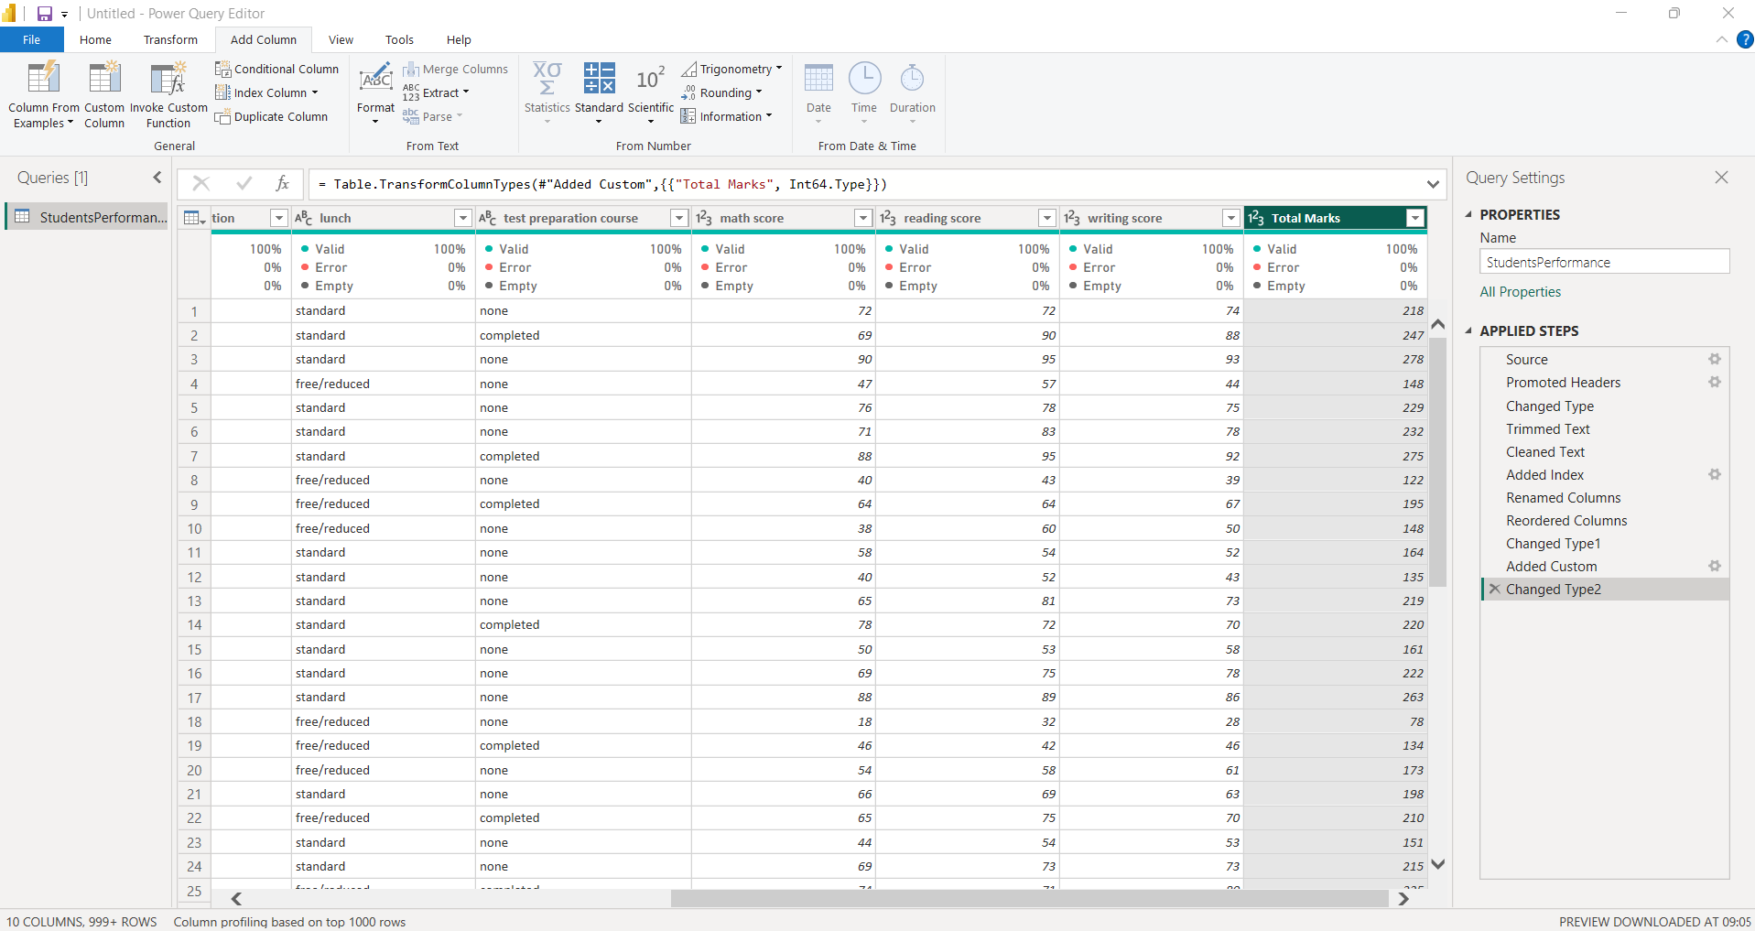
The Total Marks column was added successfully to the dataset. It contains the combined score of math, reading and writing for each student.
Creating Average Marks
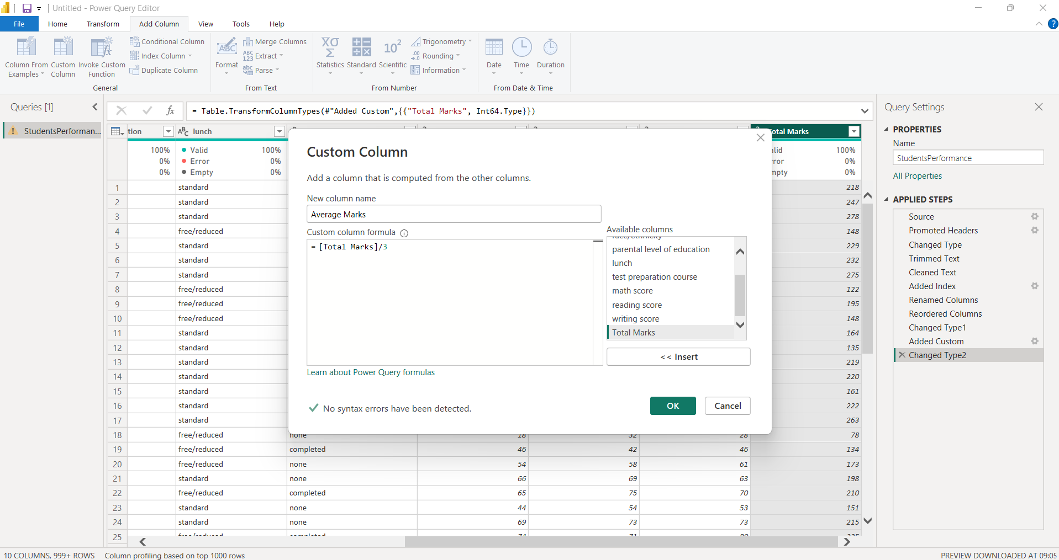
A custom column named Average Marks was created by dividing the Total Marks by 3.
The formula used was:
[Total Marks] / 3
This calculates the average score of each student across the three subjects.

Average Marks Column
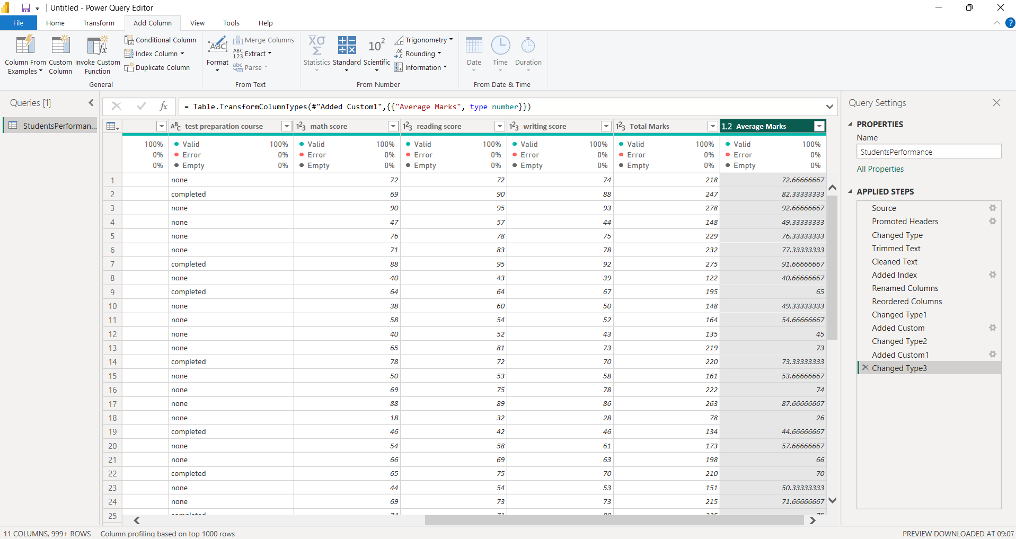
The Average Marks column was added to the dataset. The values represent the average performance of each student across math, reading and writing.
Creating Grade
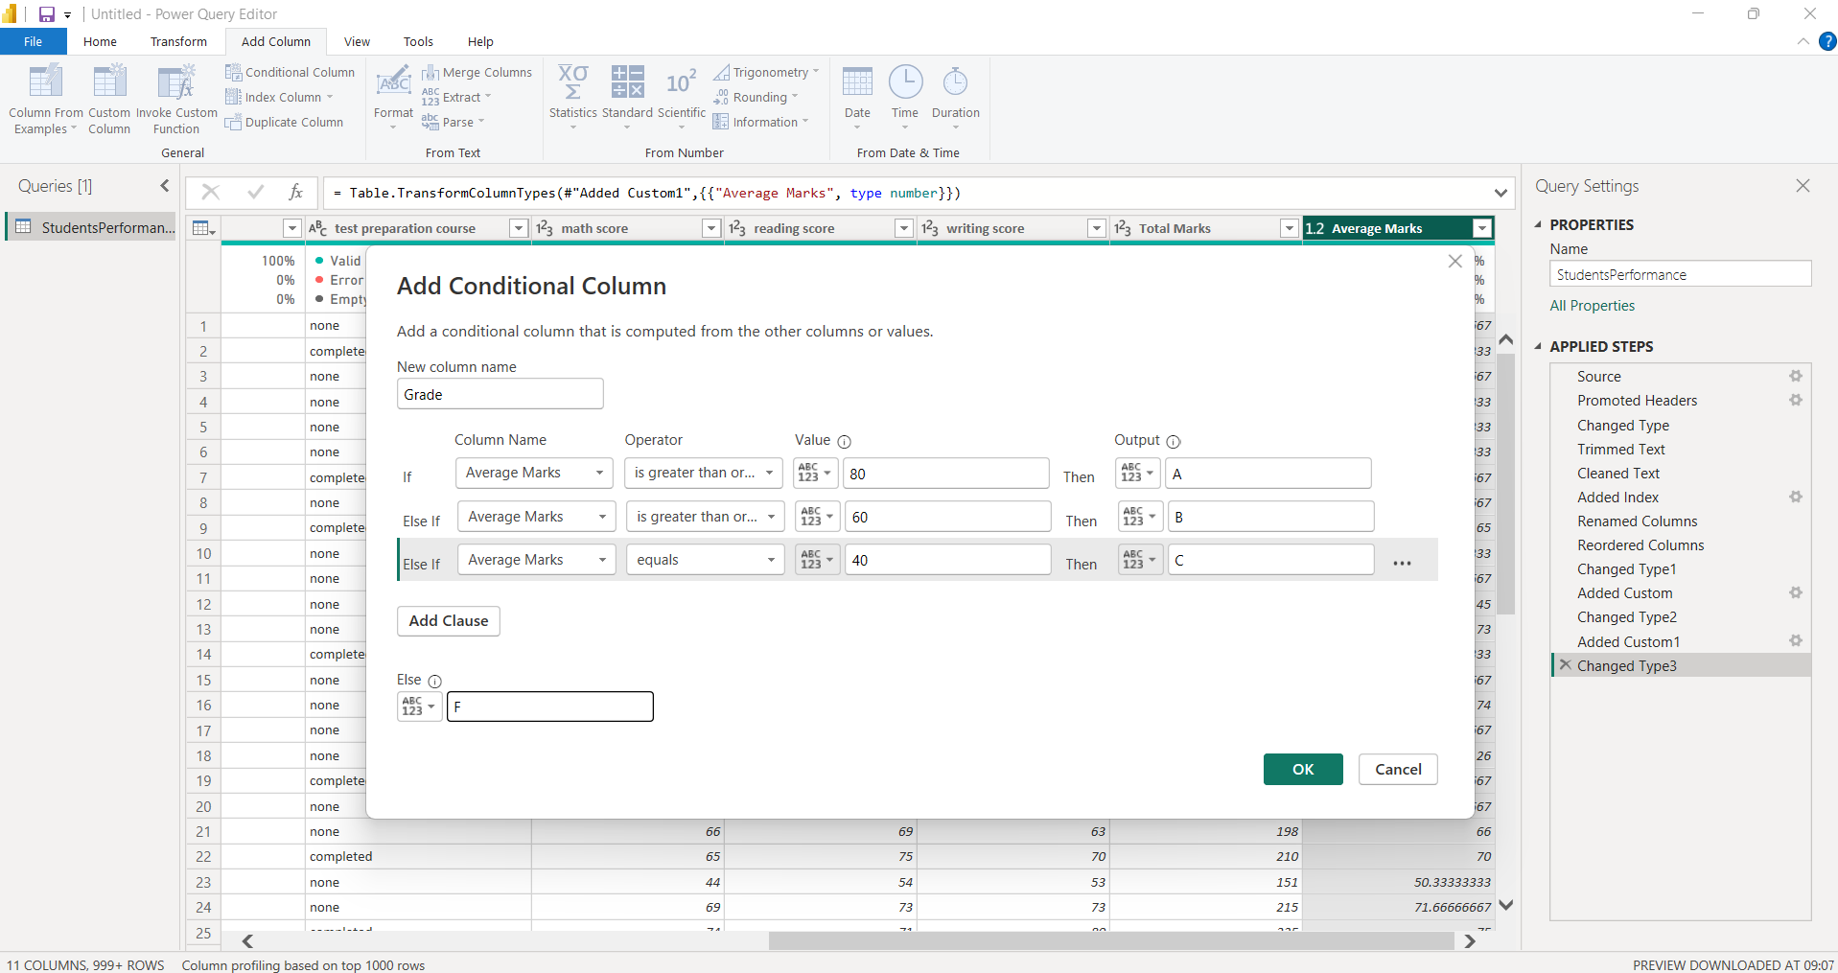
A conditional column named Grade was created based on Average Marks.
The grading conditions used were:
- Average Marks ≥ 80 → A
- Average Marks ≥ 60 → B
- Average Marks = 40 → C
- Otherwise → F
This column categorizes students based on their average performance.

Grade Column
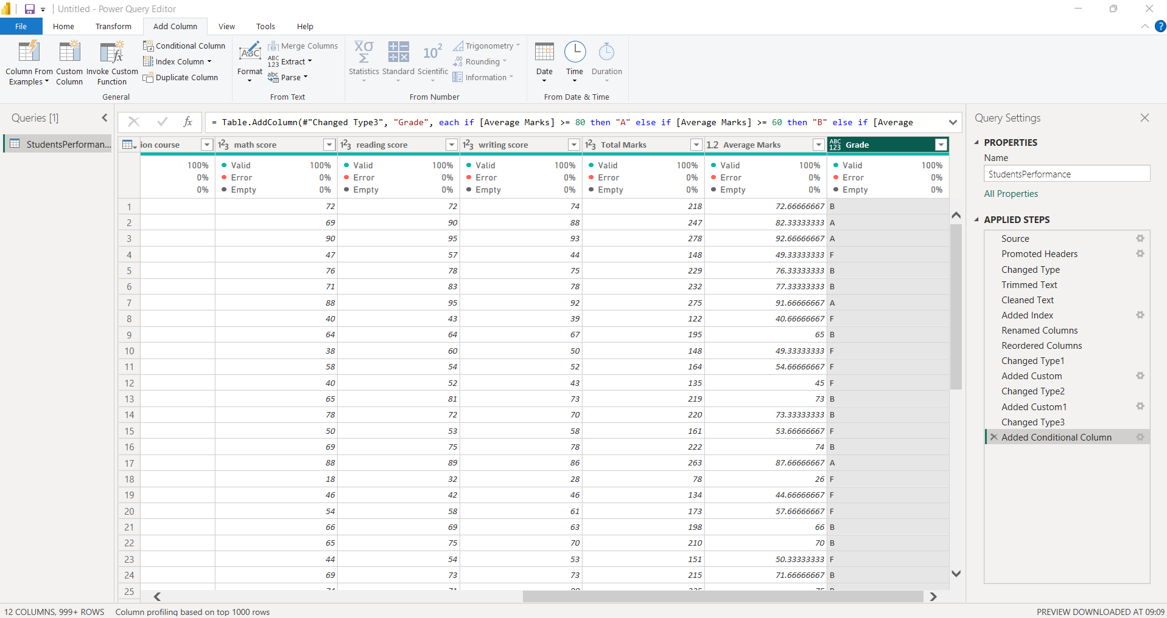
The Grade column was added successfully. Each student is assigned a grade based on their calculated Average Marks.

Creating Pass/Fail Result
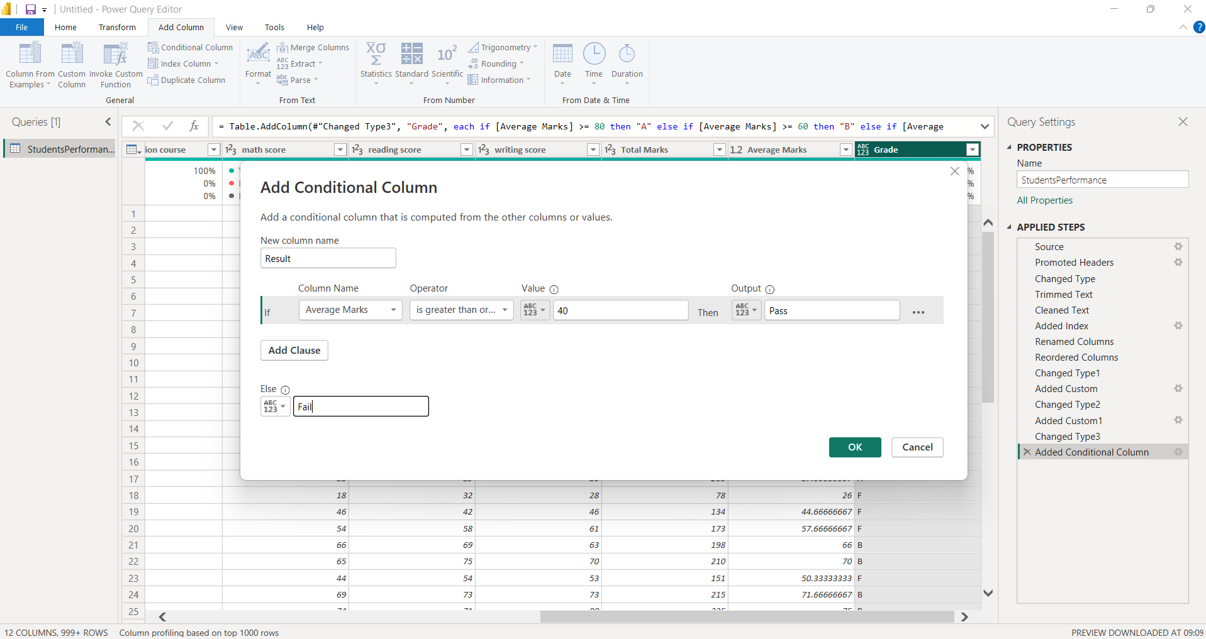
A conditional column named Result was created using Average Marks.
The condition used was:
- Average Marks ≥ 40 → Pass
- Otherwise → Fail
This was used to identify whether each student met the minimum passing requirement.

Result Column
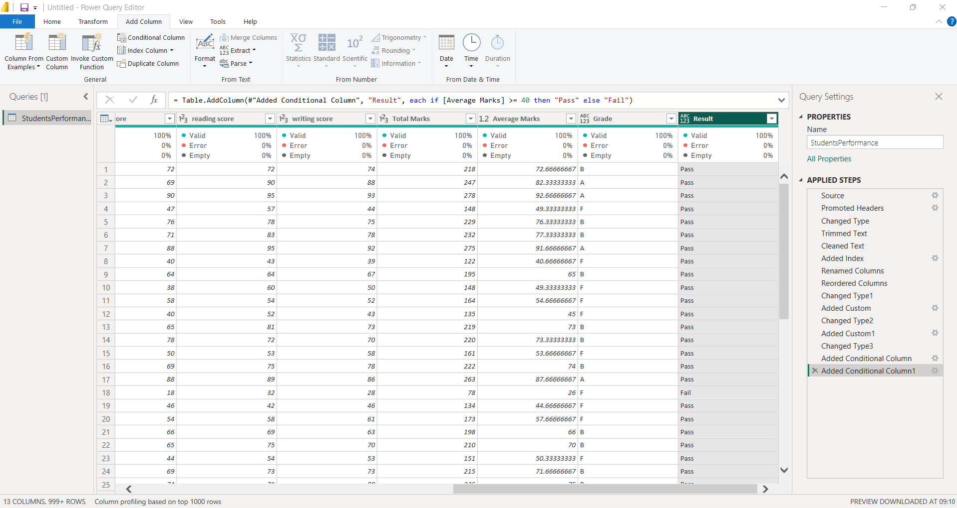
The Result column was added successfully. Students with an Average Marks value of 40 or above are marked as Pass, while the remaining students are marked as Fail.

Selecting Student Marks Columns
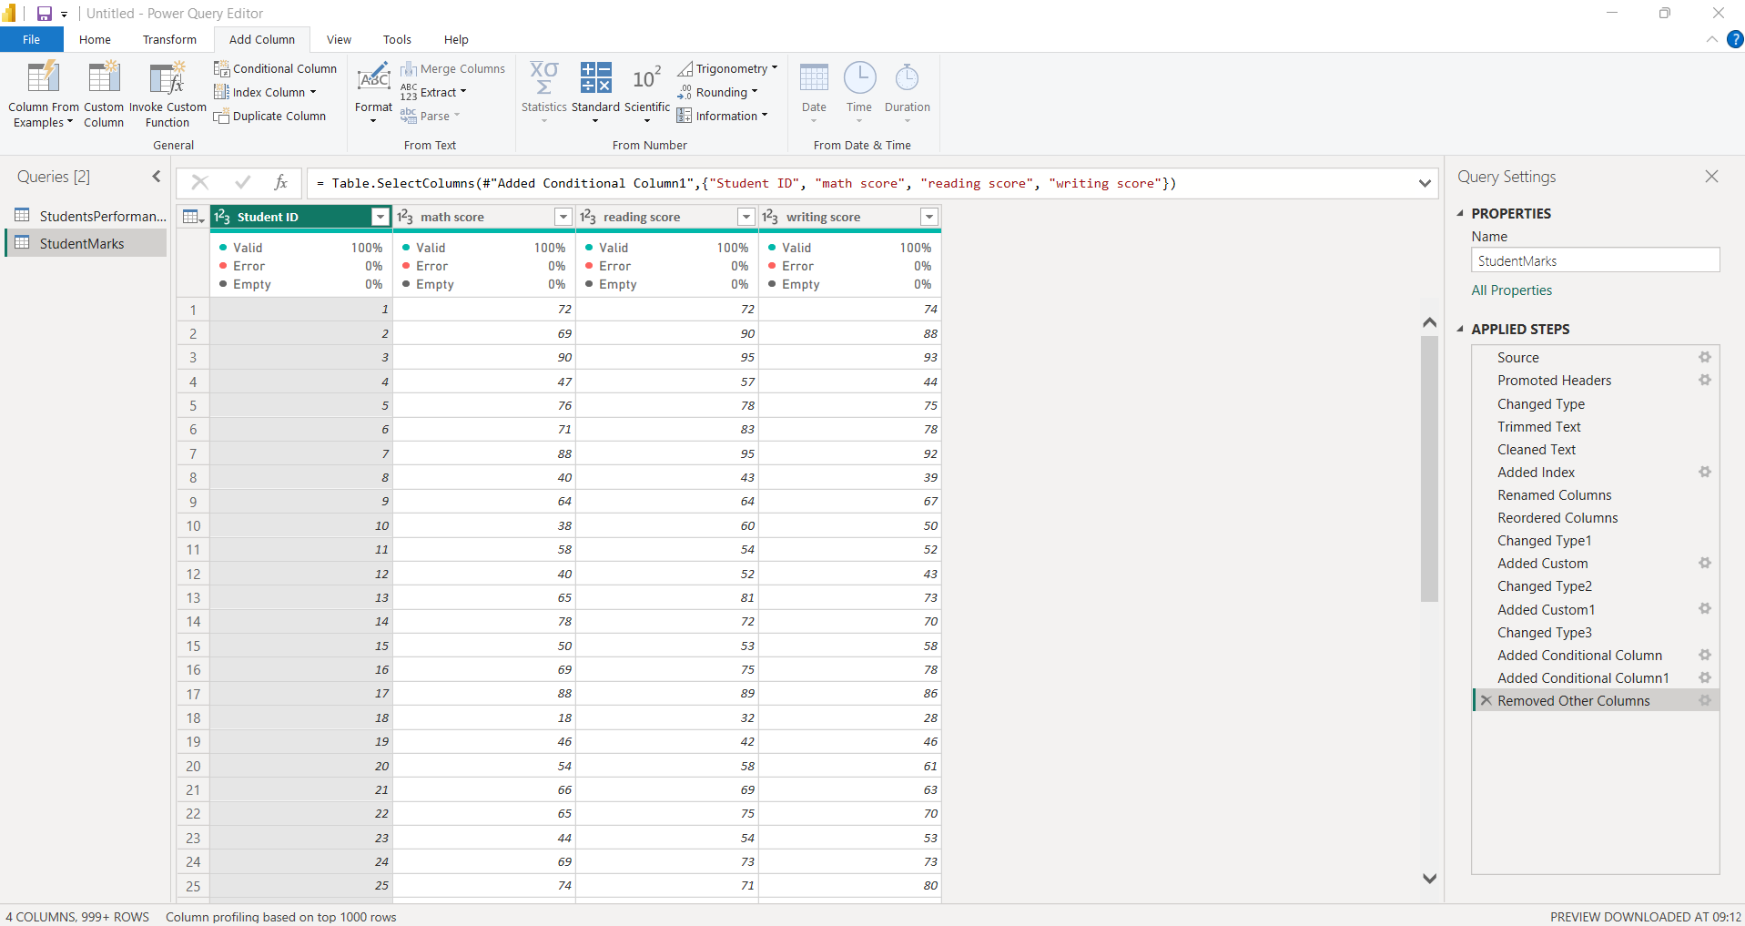
A separate query named StudentMarks was created by keeping only the columns required for score analysis:
- Student ID
- Math Score
- Reading Score
- Writing Score
This separates the subject score information from the other student details.

Unpivoting Score Columns
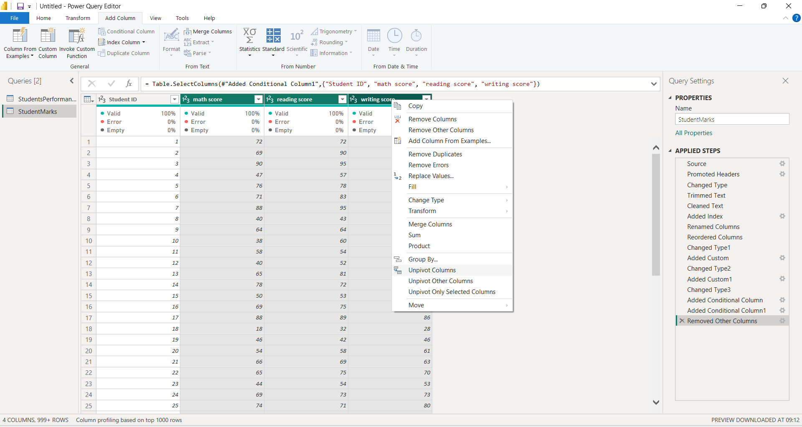
The three subject score columns were selected and the Unpivot Columns option was used. This converts the separate subject columns into rows, making the data easier to analyse by subject.

Renaming Unpivoted Columns
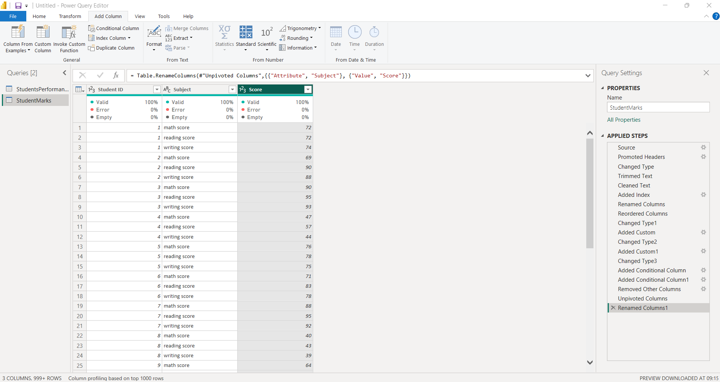
After unpivoting, the Attribute column was renamed to Subject and the Value column was renamed to Score.
The resulting StudentMarks table contains:
- Student ID
- Subject
- Score
This creates a more flexible structure for analysing scores across different subjects.

Creating StudentDetails
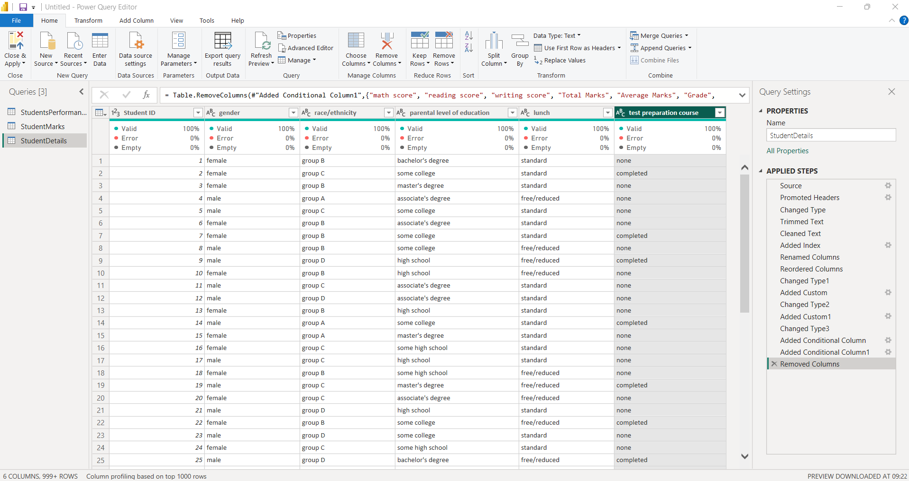
A separate StudentDetails table was created by removing the score-related and calculated columns from the original table.
The table retains the main student information such as:
- Student ID
- Gender
- Race/Ethnicity
- Parental Level of Education
- Lunch
- Test Preparation Course
This separates student details from the marks data.

Creating Measures Student Table
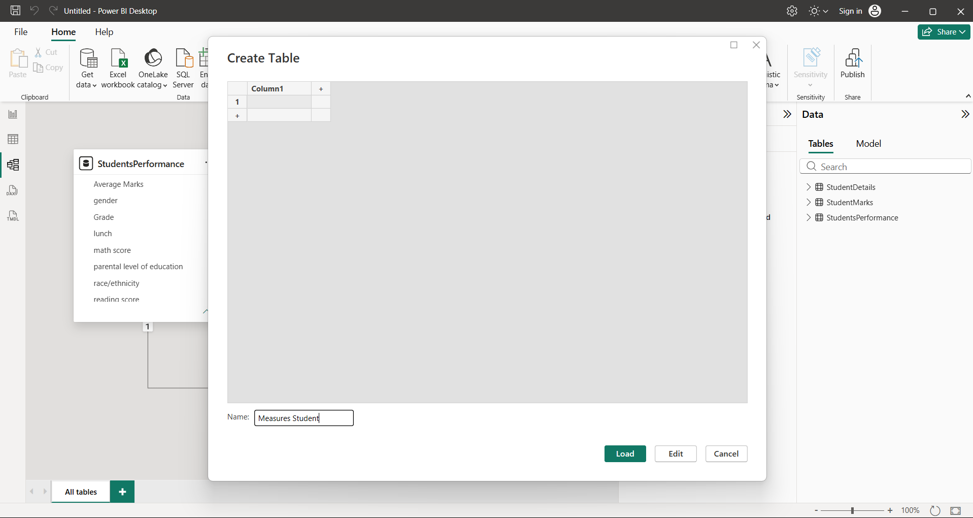
A separate table named Measures Student was created to store the DAX measures. Keeping the measures in a separate table helps organize the calculations used for analysis.

Average Math Score
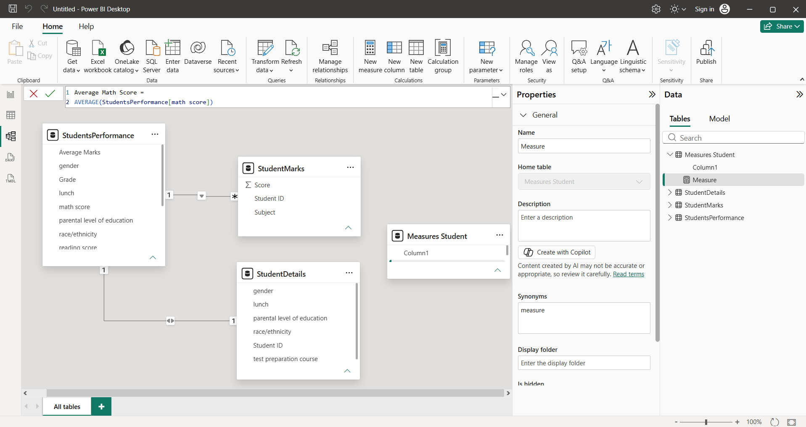
The Average Math Score measure was created using the AVERAGE function.
Average Math Score =
AVERAGE(StudentsPerformance[math score])
This measure calculates the average math score of the students.
Average Reading Score
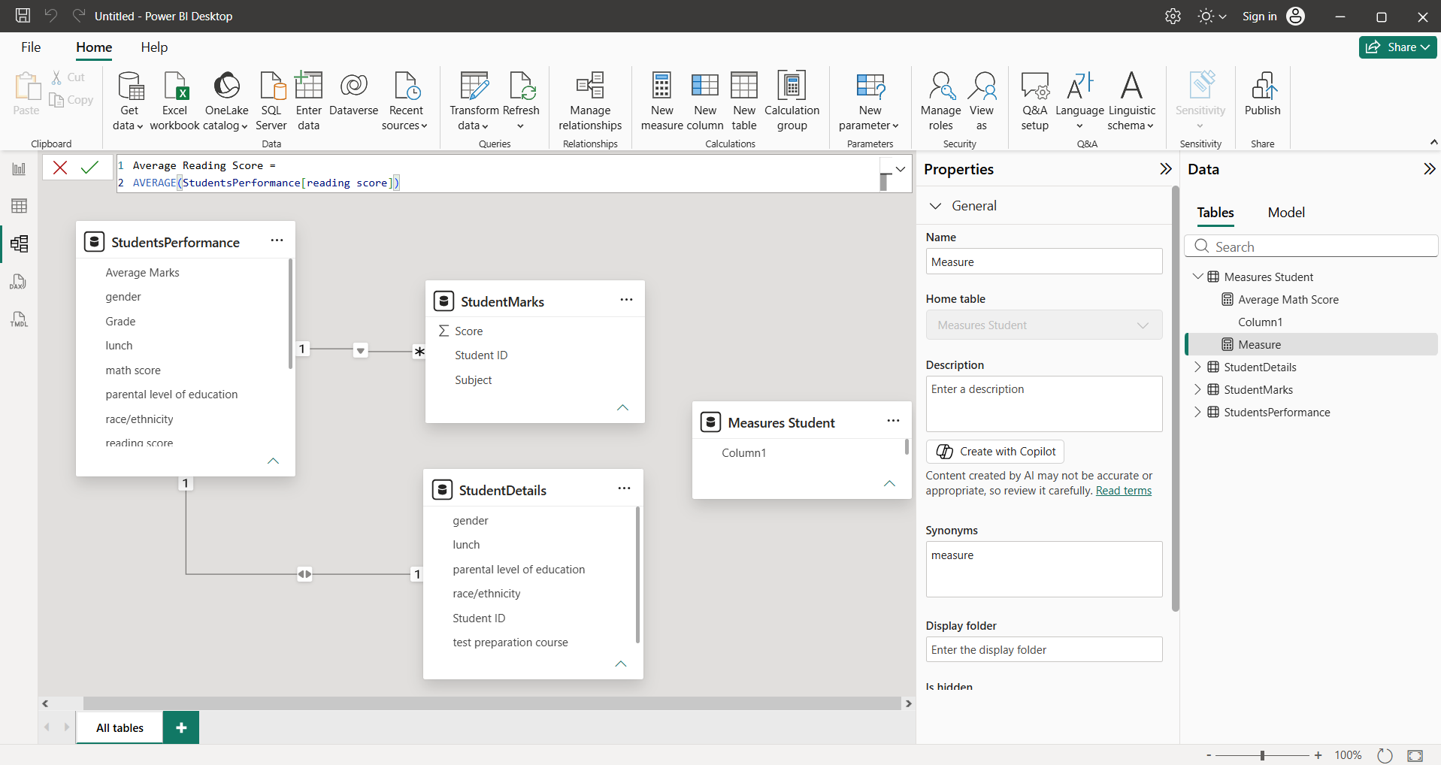
The Average Reading Score measure was created using the AVERAGE function.
Average Reading Score =
AVERAGE(StudentsPerformance[reading score])
This measure calculates the average reading score of the students.

Average Writing Score
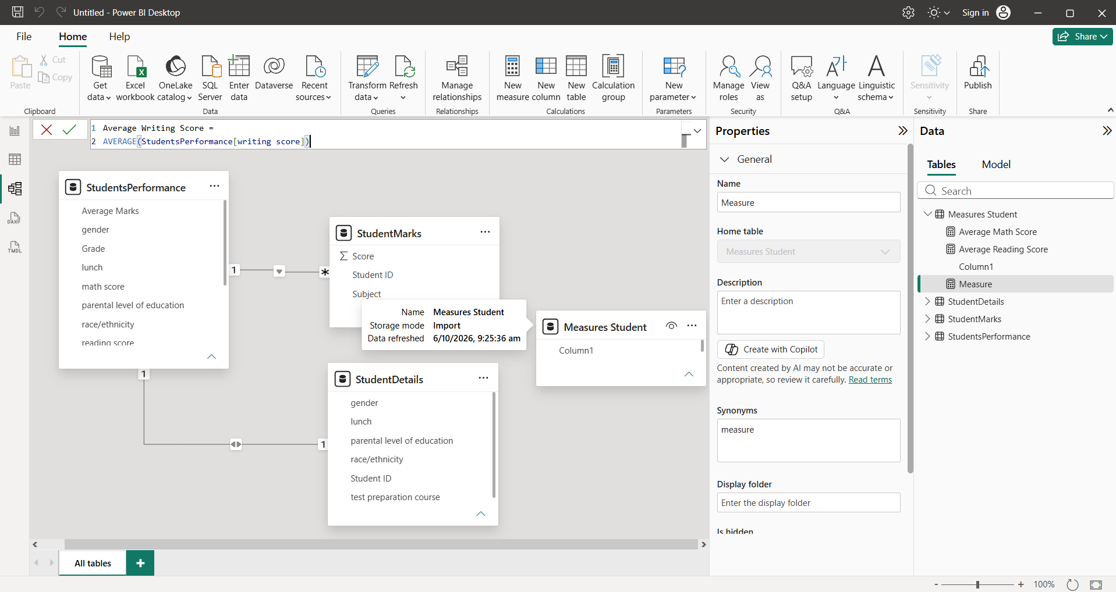
The Average Writing Score measure was created using the AVERAGE function.
Average Writing Score =
AVERAGE(StudentsPerformance[writing score])
This measure calculates the average writing score of the students.

Overall Average Score
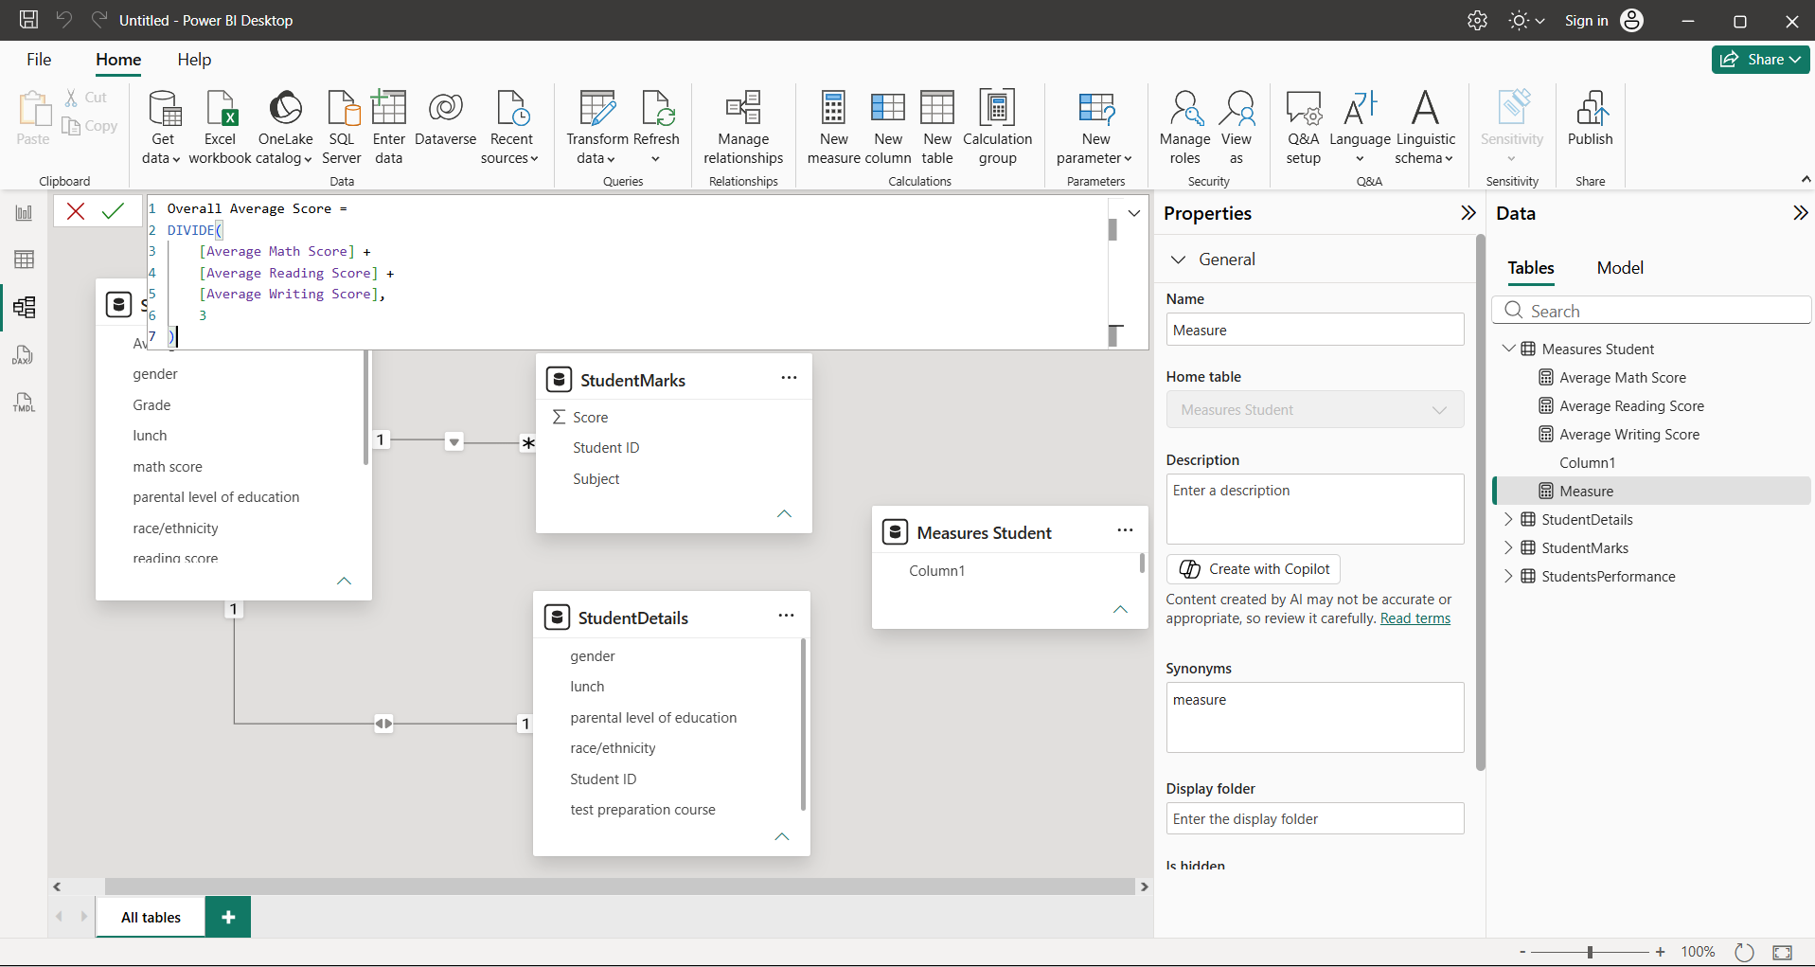
The Overall Average Score measure was created by taking the average of the three subject-level average scores.
Overall Average Score =
DIVIDE(
[Average Math Score] +
[Average Reading Score] +
[Average Writing Score],
3
)
This provides an overall average score across math, reading and writing.

Overall Pass %
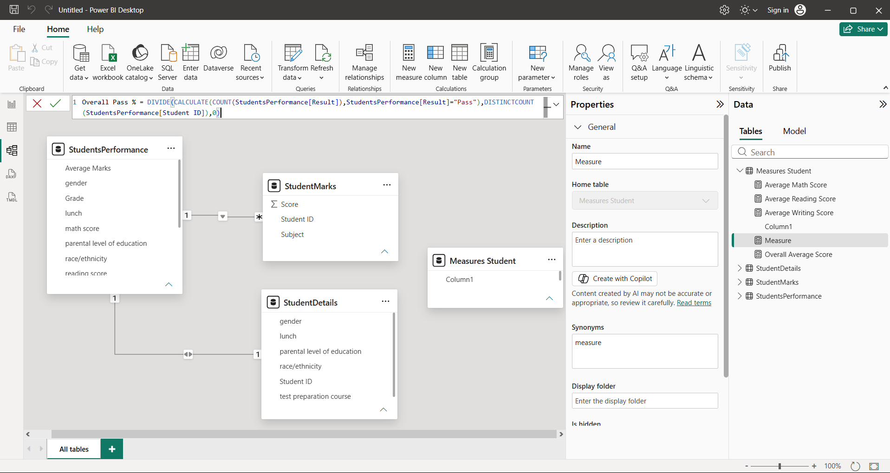
The Overall Pass % measure was created to calculate the percentage of students whose result is marked as Pass.
Overall Pass % =
DIVIDE(
CALCULATE(
COUNT(StudentsPerformance[Result]),
StudentsPerformance[Result] = "Pass"
),
DISTINCTCOUNT(StudentsPerformance[Student ID]),
0
)
This measure compares the number of students who passed with the total number of students.

Final Data Model
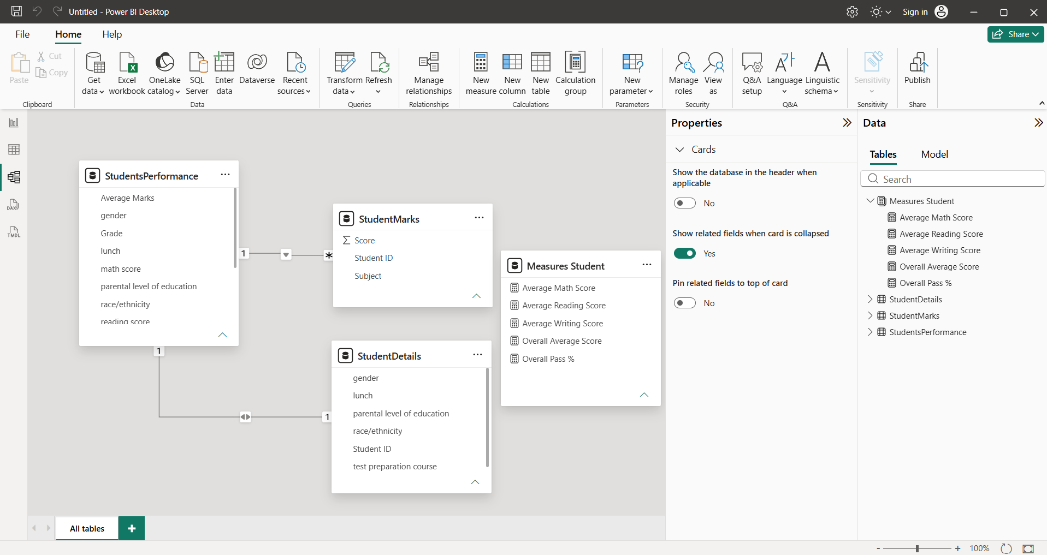
The final Power BI model contains the main StudentsPerformance table along with the StudentMarks, StudentDetails and Measures Student tables.
The StudentMarks table contains the subject-wise score information, while StudentDetails contains the main student information. The Measures Student table stores the DAX measures created for analysis.
The final model provides a structured way to analyse student performance and calculate overall academic metrics.

